### Occupation Overview



Web and Digital Interface

Designers

**in Washington**

**Lightcast Q1 2023 Data Set |** [**www.economicmodeling.com**](http://www.economicmodeling.com/)

**Contents**

What is Lightcast Data? 1

**. .**

**. . . . . . . . . . . . . . . . . . . .**

Report Parameters 2

**. .**

**. . . . . . . . . . . . . . . .**

Executive Summary 3

**. .**

**. . . . . . . . . . . . . . . . .**

Jobs 4

**. .**

**. . . . .**

Compensation 7

**. .**

**. . . . . . . . . . . .**

Job Posting Activity 8

**. .**

**. . . . . . . . . . . . . . . .**

Demographics 13

**. . .**

**. . . . . . . . . . . .**

Occupational Programs 17

**. . .**

**. . . . . . . . . . . . . . . . . . . .**

Appendix A 20

**. . .**

**. . . . . . . . . .**

# What is Lightcast Data?

#### Lightcast data is a hybrid dataset derived from official government sources such as the US Census Bureau, Bureau of Economic Analysis, and Bureau of Labor Statistics. Leveraging the unique strengths of each source, our data modeling team creates an authoritative dataset that captures more than 99% of all workers in the United States. This core offering is then enriched with data from online social profiles, resumés, and job postings to give you a complete view of the workforce.

#### Lightcast data is frequently cited in major publications such as The Atlantic, Forbes, Harvard Business Review, The New York Times, The Wall Street Journal, and USA Today.



# Report Parameters

## 1 Occupation

15-1255 Web and Digital Interface Designers

## 1 State

53 Washington

## Class of Worker

QCEW Employees and Non-QCEW Employees

#### The information in this report pertains to the chosen occupation and geographical area.

# Executive Summary

## Aggressive Job Posting Demand Over a Deep Supply of Regional Jobs

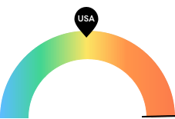

**14,941**

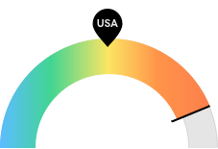

**$150,051**

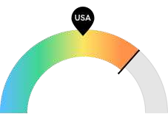

**67**

#### Jobs (2021)

Washington is a hotspot for this kind of job. The national average for an area this size is 2,035* employees, while there are 14,941 here.

#### Compensation

Earnings are high in Washington. The national median salary for Web and Digital Interface Designers is $79,893, compared to $150,051 here.

#### Job Posting Demand

Job posting activity is high in Washington. The national average for an area this size is 35* job postings/mo, while there are 67 here.

**\*National average values are derived by taking the national value for Web and Digital Interface Designers and scaling it down to account for the difference in overall workforce size between the nation and Washington. In other words, the values represent the national average adjusted for region size.**

# Jobs

## Regional Employment Is Higher Than the National Average

An average area of this size typically has 2,035* jobs, while there are 14,941 here. This higher than average supply of jobs may make it easier for workers in this field to find employment in your area.

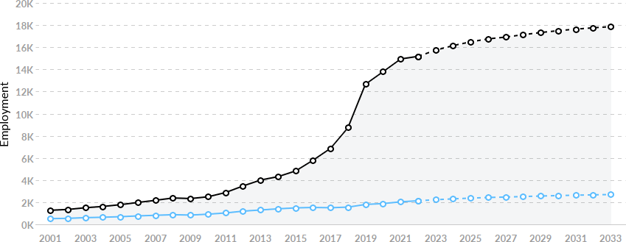

|  |  |  |  |  |
| --- | --- | --- | --- | --- |
| **Region** | **2021 Jobs** | **2030 Jobs** | **Change** | **% Change** |
| * **Washington** | **14,941** | **17,496** | **2,555** | **17.1%** |
| * **National Average** | **2,035** | **2,599** | **564** | **27.7%** |

**\*National average values are derived by taking the national value for Web and Digital Interface Designers and scaling it down to account for the difference in overall workforce size between the nation and Washington. In other words, the values represent the national average adjusted for region size.**

## Regional Breakdown

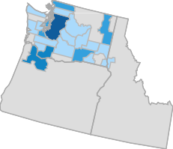

|  |  |
| --- | --- |
| **MSA** | **2021 Jobs** |
| **Seattle-Tacoma-Bellevue, WA** | **14,028** |
| **Portland-Vancouver-Hillsboro, OR-WA** | **868** |
| **Spokane-Spokane Valley, WA** | **106** |
| **Bellingham, WA** | **71** |
| **Olympia-Lacey-Tumwater, WA** | **70** |

## Most Jobs are Found in the Software Publishers Industry Sector

|  |  |  |
| --- | --- | --- |
|  |  | **% of Occupation in Industry** |
| **Industry** | **(2021)** |
| **⬤** | **Software Publishers** | **36.6%** |
| **⬤** | **Computer Systems Design and Related Services** | **13.2%** |
| **⬤** | **Electronic Shopping and Mail-Order Houses** | **10.2%** |
| **⬤** | **Other Information Services** | **8.7%** |
| **⬤** | **Data Processing, Hosting, and Related Services** | **3.1%** |

Management, Scientific, and Technical

**⬤**

Consulting Services

2.4%

⬤ Other 25.8%

# Compensation

## Regional Compensation Is 88% Higher Than National Compensation

For Web and Digital Interface Designers, the 2021 median wage in Washington is $150,051, while the national median wage is

$79,893.

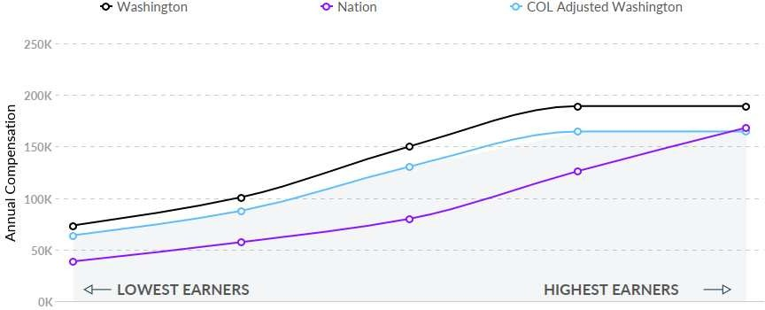

# Job Posting Activity



#### 1,598 Unique Job Postings

**The number of unique postings for this job from Jan 2021 to Dec 2022.**

#### 353 Employers Competing

**All employers in the region who posted for this job from Jan 2021 to Dec 2022.**

#### 24 Day Median Duration

**Posting duration is 7 days shorter than what's typical in the region.**

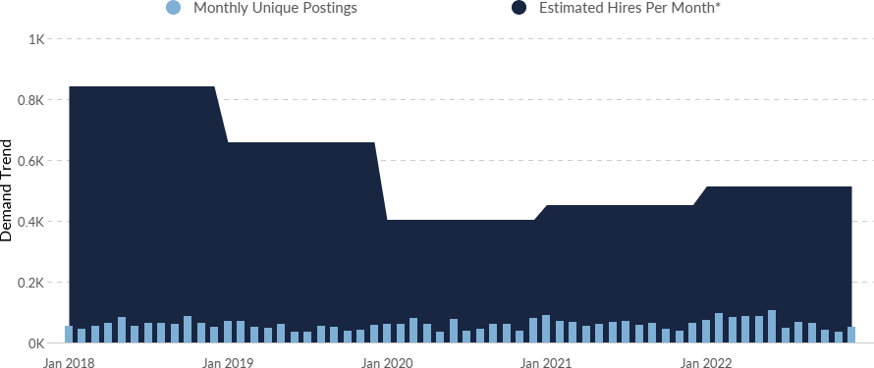

Occupation

Avg Monthly Postings (Jan 2021 - Dec

2022)

Avg Monthly Hires (Jan 2021 - Dec

2022)

Web and Digital Interface Designers

67 482

**\*A hire is reported by the Quarterly Workforce Indicators when an individual's Social Security Number appears on a company's payroll and was not there the quarter before. Lightcast hires are calculated using a combination of Lightcast jobs data, information on separation rates from the Bureau of Labor Statistics (BLS), and industry-based hires data from the Census Bureau.**

Top Companies Unique Postings Top Job Titles Unique Postings

**Amazon 118 ** **Environment Artists 183 **

**Randstad 93 ** **Game Designers 117 **

**Microsoft 56 ** **Gameplay Engineers 110 **

**Electronic Arts 48 ** **Concept Artists 78 **

**ASGN 36 ** **Content Creators 44 **

**Bungie 35 ** **Game Engineers 31 **

**Aquent 34 ** **Lead Game Designers 28 **

**CompuCom 33 ** **Environmental Artists 26 **

**Keywords Studios 31 ** **Campus Technology Specialists 23 **

**Humana 26 ** **TPM Managers 23 **

## Top Specialized Skills

 Frequency in Job Postings  Frequency in Profiles

**Project Management Workflow Management**



**Game Design**

Skills Postings

**Computer Science**

**C++ (Programming Language)**

**Agile Methodology Content Creation Adobe Photoshop Unity Engine Game Engine**

**0% 20% 40% 60% 80%**

% of Total Postings Profiles

% of Total Profiles

Project Management 4%

**%**

**13**

17

210

Workflow Management 4%

**%**

**13**

14

203

Game Design 197 12% 346 87%

Computer Science 193 12% 9 2%

C++ (Programming Language)

177 11% 47 12%

Agile Methodology 163 10% 20 5%

Content Creation 149 9% 8 2%

Adobe Photoshop 148 9% 79 20%

Unity Engine 146 9% 81 20%

Game Engine 144 9% 14 4%

## Top Common Skills

Frequency in Job Postings Frequency in Profiles

**Communications**

**Leadership Management**

Skills Postings

**Problem Solving**

**Writing Innovation Planning**

**Time Management**

**Research Operations**

**0% 10% 20% 30% 40% 50%**

% of Total Postings

Profiles

% of Total Profiles

Communications 10%

41

58%

923

Leadership 12%

47

24%

387

Management 267 17% 51 13%

Problem Solving 242 15% 11 3%

Writing 204 13% 44 11%

Innovation 199 12% 21 5%

Planning 191 12% 14 4%

Time Management 176 11% 8 2%

Research 168 11% 48 12%

Operations 167 10% 19 5%

## Top Software Skills

Frequency in Job Postings Frequency in Profiles

**C++ (Programming Language)**

**Adobe Photoshop Unity Engine**

**Microsoft Office**

**Autodesk Maya Unreal Engine**

**Autodesk 3DS Max (3D Graphics**

Skills Postings % of Total Postings

**Software)**

**AAA Video Games C# (Programming Language) Python (Programming Language)**

**0% 5% 10% 15% 20%**

Profiles

% of Total Profiles

|  |  |  |  |  |
| --- | --- | --- | --- | --- |
| **C++ (Programming**  **Language)** | **178** | **11%** | **47** | **12%** |
| **Adobe Photoshop** | **150** | **9%** | **79** | **20%** |
| **Unity Engine** | **148** | **9%** | **81** | **20%** |
| **Microsoft Office** | **134** | **8%** | **72** | **18%** |
| **Autodesk Maya** | **131** | **8%** | **43** | **11%** |
| **Unreal Engine** | **130** | **8%** | **43** | **11%** |
| **Autodesk 3DS Max (3D Graphics Software)** | **105** | **7%** | **18** | **5%** |

AAA Video Games 101 6% 1 0%

C# (Programming Language)

97 6% 56 14%

Python (Programming Language)

87 5% 22 6%

# Demographics

## Retirement Risk Is Low, While Overall Diversity Is About Average

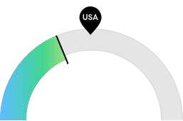

**711**

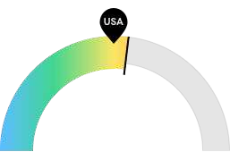

**5,758**

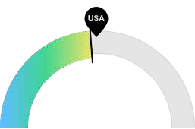

**5,198**

#### Retiring Soon

Retirement risk is low in Washington. The national average for an area this size is 1,050* employees 55 or older, while there are 711 here.

#### Racial Diversity

Racial diversity is high in Washington. The national average for an area this size is 5,164* racially diverse employees, while there are 5,758 here.

#### Gender Diversity

Gender diversity is about average in Washington. The national average for an area this size is 5,570* female employees, while there are 5,198 here.

**\*National average values are derived by taking the national value for Web and Digital Interface Designers and scaling it down to account for the difference in overall workforce size between the nation and Washington. In other words, the values represent the national average adjusted for region size.**

## Occupation Age Breakdown

|  |  |  |  |
| --- | --- | --- | --- |
|  | | **% of Jobs** | **Jobs** |
| **⬤** | **14-18** | **0.4%** | **55** |
| **⬤** | **19-24** | **5.7%** | **866** |
| **⬤** | **25-34** | **42.5%** | **6,455** |
| **⬤** | **35-44** | **32.7%** | **4,969** |
| **⬤** | **45-54** | **14.0%** | **2,124** |
| **⬤** | **55-64** | **4.0%** | **610** |
| **⬤** | **65+** | **0.7%** | **101** |

## Occupation Race/Ethnicity Breakdown

|  |  |  |  |
| --- | --- | --- | --- |
|  | | **% of Jobs** | **Jobs** |
| **⬤** | **White** | **62.1%** | **9,421** |
| **⬤** | **Asian** | **24.7%** | **3,747** |
| **⬤** | **Hispanic or Latino** | **6.5%** | **980** |
| **⬤** | **Two or More Races** | **4.0%** | **613** |
| **⬤** | **Black or African American** | **2.4%** | **362** |
| **⬤** | **Native Hawaiian or Other Pacific Islander** | **0.2%** | **28** |
| **⬤** | **American Indian or Alaska Native** | **0.2%** | **28** |

## Occupation Gender Breakdown

% of Jobs Jobs

⬤ Males 65.8% 9,981

⬤ Females 34.2% 5,198

## National Educational Attainment

|  |  |  |
| --- | --- | --- |
|  | | **% of Jobs** |
| **⬤** | **Less than high school diploma** | **0.8%** |
| **⬤** | **High school diploma or equivalent** | **5.9%** |
| **⬤** | **Some college, no degree** | **15.0%** |
| **⬤** | **Associate's degree** | **9.3%** |
| **⬤** | **Bachelor's degree** | **53.9%** |
| **⬤** | **Master's degree** | **14.1%** |
| **⬤** | **Doctoral or professional degree** | **1.0%** |

# Occupational Programs



#### 13 Programs

**Of the programs that can train for this job, 13 have produced completions in the last 5 years.**

#### 3,890 Completions (2021)

**The completions from all regional institutions for all degree types.**

#### 1,478 Openings (2021)

**The average number of openings for an occupation in the region is 680.**

CIP Code Top Programs Completions (2021)

11.0701 Computer Science 1,704 

11.0101 Computer and Information Sciences, General 746 

11.0201 Computer Programming/Programmer, General 344 

11.0801 Web Page, Digital/Multimedia and Information Resources D… 332 

09.0702 Digital Communication and Media/Multimedia 297 

50.0401 Design and Visual Communications, General 261 

11.0202 Computer Programming, Specific Applications 128 

11.1004 Web/Multimedia Management and Webmaster 43

50.0409 Graphic Design 29

52.1404 Digital Marketing 4

Top Schools Completions (2021)

University of Washington-Seattle Campus 766 

Washington State University 392 

University of Washington-Bothell Campus 319 

Seattle University 254 

University of Washington-Tacoma Campus 249 

Western Washington University 189 

Saint Martin's University 177 

Eastern Washington University 154 

Green River College 112 

DigiPen Institute of Technology 88 

# Appendix A

Web and Digital Interface Designers (SOC 15-1255):

Design digital user interfaces or websites. Develop and test layouts, interfaces, functionality, and navigation menus to ensure compatibility and usability across browsers or devices. May use web framework applications as well as client-side code and processes. May evaluate web design following web and accessibility standards, and may analyze web use metrics and optimize websites for marketability and search engine ranking. May design and test interfaces that facilitate the human-computer interaction and maximize the usability of digital devices, websites, and software with a focus on aesthetics and design. May create graphics used in websites and manage website content and links. Excludes Special Effects Artists and Animators (27- 1014) and Graphic Designers (27-1024).

Sample of Reported Job Titles:

Web Designer Webmaster Web Developer

Web Design Specialist Web Architect

Game Designer World Designer Level Designer Gamemaster

Game Design Consultant

Related O*NET Occupations:

Web and Digital Interface Designers (15-1255.00) Video Game Designers (15-1255.01)